

COMMUNITY COLLEGE OF CITY UNIVERSITY

DIVISION OF APPLIED SCIENCE AND TECHNOLOGY

AST20613 Computer System Development

2014-2015

V. Calendar

(Voice Calendar)

FINAL YEAR PROJECT

USER MANUAL

by

Group:ISD02

WONG, Ho Long(53587834)*

LI, Sing Lun (53612386)

SIN, Sin Chung(53587350)

WONG, Chun Kit(53581516)

Supervised by

Dr. Timothy Kwong

**TABLE OF CONTENTS**

**1. INTRODUCTION**

1.1 OBJECTIVES

1.2 MINIMUM SYSTEM REQUIREMENTS

1.3 RECOMMENDED SYSTEM REQUIREMENTS

1.4 SOFTWARE REQUIREMENTS

**2. SYSTEM FUNCTION**

2.1 ACCOUNT REGISTRATION

2.2 LOGIN

2.3 VOICE INPUT

2.4 VOICE OUTPUT

2.5 CREATE EVENT

2.6 EDIT EVENT

2.7 EMAIL TO ADMINISTRATOR

2.8 INFORMATION PAGE

**ACKNOWLEDGEMENTS**

1. **INTRODUCTION**
   1. **Objectives**

This is a guideline to teach users how to use Google Voice Calendar on their mobile device. The following shows the functions that users can use when they browse the web page with network access.

1. Voice Input
2. Voice Output
3. Create Event
4. Edit Event
5. Delete Event
6. Email to administrators
7. Information Page

**1.2 Minimum System Requirements**

Please make sure that the computer on which you plan to be the server of Voice Calendar(VCal) meets the minimum system requirements for the program to run:

**For computer users:**

* Windows® System XP / XP x64 / Vista / Vista x64 / 7 OS (with the latest Service or updates):
* Intel Pentium 4 1.3 GHz or AMD Athlon XP 1500+
* 1 GB or more of RAM
* 1 GB available hard disk space (for installation)
* 20GB available hard disk space (for system running)
* 4X DVD-ROM drive
* Broadband Internet connection
* Microphone
* Keyboard/mouse NOTE

**For mobile users:**

* Android 2.2 or above
* ARM Cortex A8 600 MHz
* 256 MB RAM
* 10 MB storage
* Broadband Internet connection
* Microphone included

**1.3 Recommended System Requirements**

**For computer users:**

* Windows® System Vista x64 / Windows 7 OS:
* Dual-core processor, such as the Intel Pentium D or AMD Athlon 64 X2
* 2 GB RAM
* 2 GB available hard disk space (for installation)
* 60 GB available hard disk space (for system running)
* 4X DVD-ROM drive
* Broadband Internet connection
* Microphone
* Keyboard/mouse

**For mobile users:**

* Android 2.2 or above
* ARM Cortex A8 600 MHz
* 256 MB RAM
* 10 MB storage
* Broadband Internet connection
* Microphone included

**1.4 Software Requirements**

Since this voice calendar is only available on Google Chrome to use, the devices of users need to be installed Google Chrome for the web browser to search the web site of the calendar.

1. **SYSTEM FUNCTION**

**2.1 Account Registration**

For the registration page, users can also use their voice to input all of the details that need to register an account like username, user email, password and repeat password. There is a limitation for the username, users can only user numbers or letters for username and only can be 2 to 64 character. There is an instruction in the text field for users to know (shown at Figure 2.1).

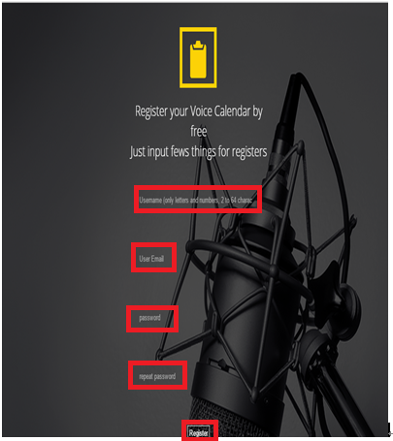

**Figure 2.1** Account Registration

**2.2 Login**

For the login page, users can use their voice to input their username password. Also they can use the voice to do login function after inputting the username and password. There is a microphone and login button (shown at Figure 2.2) for users to click or they can choose use voice to login.

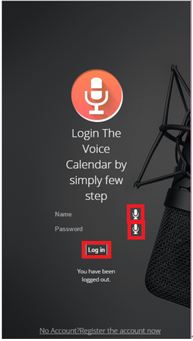

**Figure 2.2** Login

**2.3 Voice Input**

Users can use their voice to input the details of the event. The system will help them to convert the voice to the text and show it out to the screen. There is a button like microphone (shown at Figure 2.3) for users to click and let users for using voice to input details.

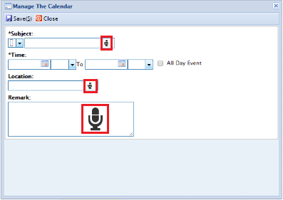

**Figure 2.3** Voice Input

**2.4 Voice output**

After login the system, there will be a page to show that users can click the button to check their schedule (shown at Figure 2.4). After clicking that button, the system will go to next page and have a “Listen Schedule with Google Server” button (shown at Figure 2.5) that users can click or users use their voice say speak. The system will speak out today schedule for these two methods.

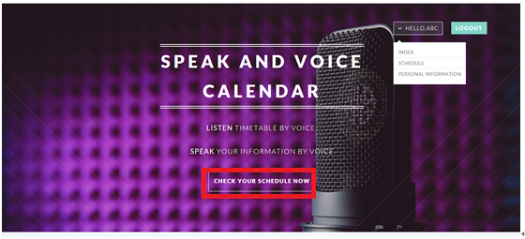

**Figure 2.4** After login

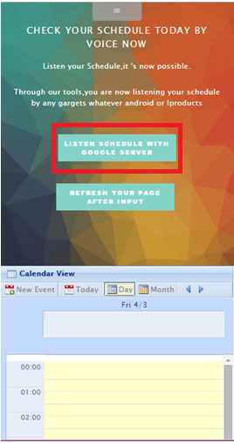

**Figure 2.5** Voice output

**2.5 Create Event**

Users can use voice or click the New Event button first and the system will show out that users need to input those information to create a new event in their calendar (shown at Figure 2.6 mark them by the number). It helps users to create their event into the calendar step by step.

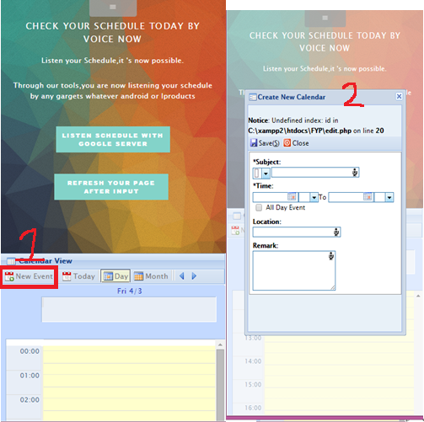

**Figure 2.6** Create event

**2.6 Edit Event**

Users can use voice or click the event first and the system will show out that users need to choose “Delete” or “Edit details” button to have a following action (shown at Figure 2.7 mark them by number). And then, users can use voice or click “Edit details” button, the system will show the details of an event as Figure 2.8.

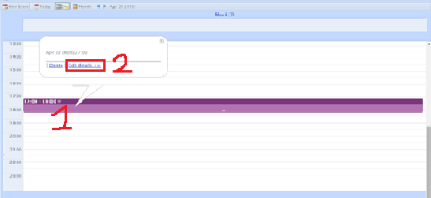

**Figure 2.7** Edit event

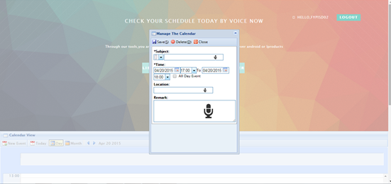

**Figure 2.8** Edit details of event

**2.7 Delete Event**

Users can use voice or click the event first and the system will show out that users need to choose “Delete” or “Edit details” button to have a following action first (shown at Figure 2.9 mark them by number). And then, users can use voice or click “Delete” button and the system will show out the option yes or cancel button for people to choose to delete the event or not (shown at Figure 2.10).

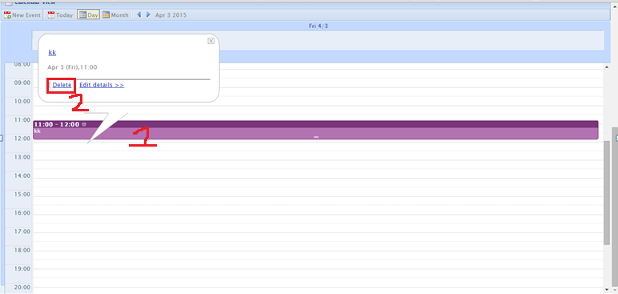

**Figure 2.9** Delete event

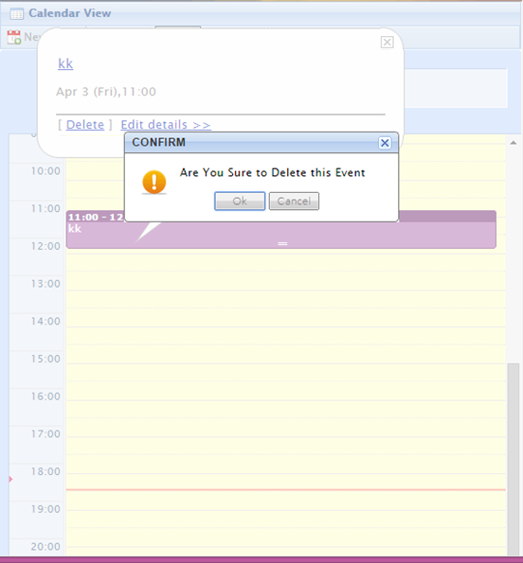

**Figure 2.10** Confirm to delete event

**2.8 Administrators Page**

The user have right for send the email to the administrators,as well as they may have account problems or as well as the add/drop event problems,the email may directly send to the Administrator Email box.

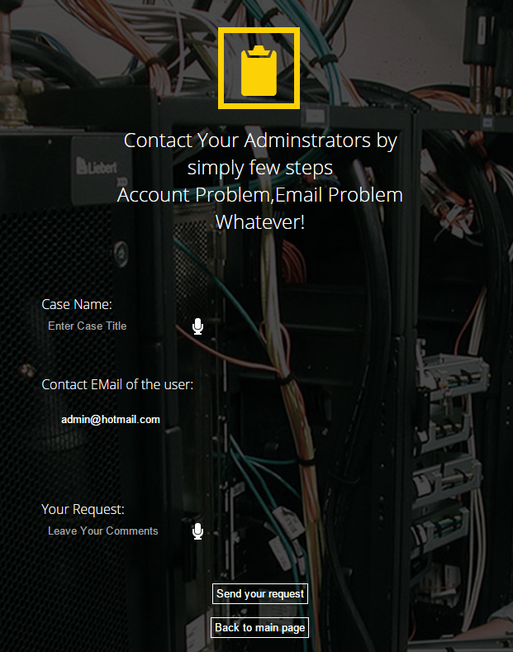

**Fig 2.11** Administrator Contact Page

**2.9. Information Page**

The user have right for check their personal information as well as their login name and their email that the information comes from register process.

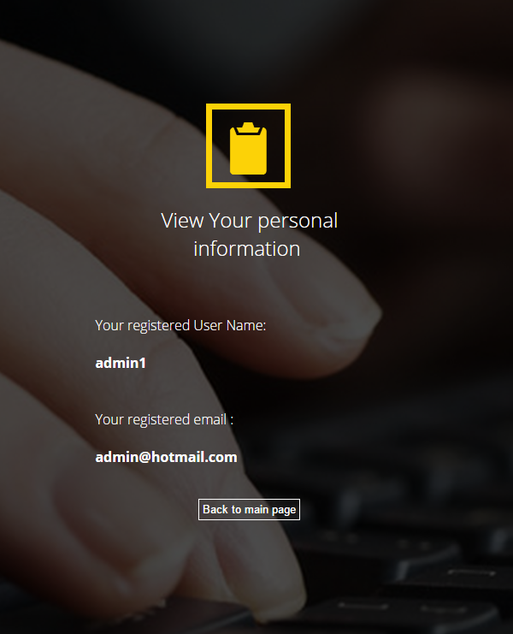

**Fig 2.12** Personal Information Page

**ACKNOWLEDGEMENTS**

We have taken efforts in this project, it would not have been possible without the kind help and support of many individuals and organizations. We would like to take this chance to extend our sincere thanks of all of them.

We are very thankful to our supervisor, Dr.Timothy Kwong, the guide of the project that help us to solve many problems throughout the project. Also, we are highly indebted for his guidance and constant supervision as well as for providing necessary information regarding the project and also for his support in completing the project. Moreover, his kind concern provides much power to our team to finish the project successfully.

We would also like to express our special gratitude and thanks to the teachers who have taught us in these two years. The knowledge they have taught us is very useful in this project and it helps to fix lots of issues.

The teachers that we owe a great many thanks are: (Names are listed in alphabetical order)

Dr. Desmond Tsoi

Mr. Frank Lau

Mr. Jackie Kwong

Dr. Kenny Ma

Dr. Timothy Kwong

We would also like to thank you all of our groupmates, with all the help and support for doing the development of the project.

Thank you.

Yours sincerely,

Wong Ho Long, Li Sing Lun, Sin Sin Chung, Wong Chun Kit

FYP ISD-02 V. Calendar